A+ Computer Science By:Shria Kondragunta Lab Value - 100

Lab Goal: To use all of the concepts learn from units 1 through 4.

Lab Description: It is spring time and all the Jeroos want to go flower picking. Unfortunately the flowers are surrounded by nets. Many of the Jeroos have tried but have failed. Alex is determined to get the flowers. Help Alex take down the nets and move all of the flowers toward the South side of the island. Use many if not all the concepts learned in units 1-4. In the End make sure that Alex is in the location (12,9), so she can show off what she did to the other Jeroos.

Start Screen:
Files Needed ::
Blank File
protect.jev
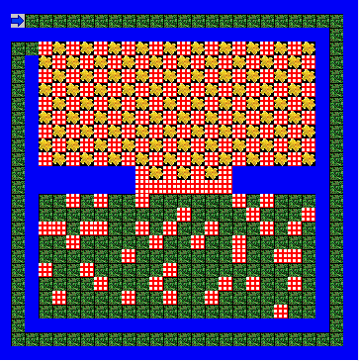
algorithm help

Analyze – what tasks do I need to do.

What must each method accomplish?

How many methods do I need?

Do I need loops?

Preconditions –
- Where do I start?

Postcondition –
- Flowers are completely gone in the North.
- Nets are completely gone.

Ending Screen:

